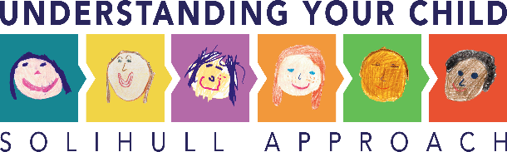
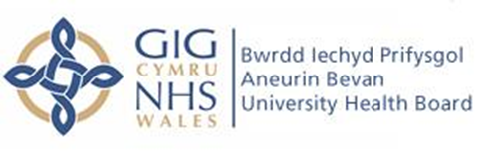

Solihull Approach Online Briefing Pack

The Solihull Online Approach is a non-profit organisation focused on improving emotional health and wellbeing by supporting relationships. The courses are evidence based with an ongoing research programme. The Solihull Approach can be used for early intervention and prevention in the early years.
The courses that are available to parents and carers range from 0 to 19+ years and have been translated into 7 different languages with google translate available for all. New courses will be added to the licensing free of charge when developed and kept updated.
The Solihull courses that are available to parents and/or carers are:
- Understanding pregnancy, labour, birth and your baby (Welsh, Urdu, Modern Standard Arabic, Polish)
- Understanding pregnancy, labour, birth and your baby: for women’s couples
- Understanding your baby (Welsh, Urdu)
- Understanding your child (Welsh, Urdu, Modern Standard Arabic, Polish, Bulgarian, Simplified Chinese, Somali)
- Understanding your child with additional needs
- Understanding you preterm or sick baby in hospital
- Understanding you preterm or sick baby now you’re home
- Understanding your teenager's brain (Welsh, Urdu, Modern Standard Arabic)
- Understanding your brain (for teenagers only)
- Understanding your feelings (for teenagers only)
- Understanding your child’s feelings (a taster course)
- Understanding your child’s mental health and wellbeing
- Understanding your relationships
- Understanding the impact of the pandemic on your child
- Understanding the impact of the pandemic on your teenager
The use of an online approach will enable practitioners to target a population with whom they have concerns with. Practitioners can work alongside the parents, or they can access the course via their account themselves.
Live data is available 24/7 and accessed through the sponsor’s account. Visual aids are used in the form of graphs and charts for data representation. The reports that can be accessed at any time are:
- Visual reports
- Learner reports (numbers of registrations and actual learners - now and over time.
- Demographic reports - the profile of registered learners ('Supplementary question report).
- ‘In-course surveys’ (friends & family satisfaction Qs asked throughout the course).
- The above for each of your postcode areas ('Challenge question report').
- Evaluation reports
- (scored and analysed questionnaire responses based on formally standardised/ published outcome measures)
- Post course surveys
-learner feedback including Satisfaction Questions and Free type comments
In addition, a monthly summary report including key information is sent via email. Annually, an infographic report will be sent highlighting the last 12 months. Access to this data enables insight into the number of registrations to actual learners, geographical information and feedback from individuals.
Parents can access these courses through www.inourplace.co.uk and inputting the unique Gwent access code GEYAP, they will then be asked a few questions to create an account. Access is non-expiry and lasts a lifetime.
Advertising for the Solihull Online Approach will begin the end of May to coincide with the DPIA sign off.

